SYSTEM REQUIREMENTS

FOR PROPOSED

HEALTH COVER

PREPARED BY:

UX TEAM, HEALTH COVER

GWARIMPA, ABUJA,

FCT – NIGERIA

MAY, 2019.

Contents

PURPOSE OF THIS DOCUMENT 3

AUDIENCE 3

INTRODUCTION 3

VALUE PROPOSITION 3

SYSTEM CONTEXT 3

USER MAP 4

ACTOR PROFILE & DESCRIPTION 4

SYSTEM PROCESS 4

REQUIREMENTS 6

Functional Requirements 6

Non-Functional Requirements 8

USE-CASES 10

SYSTEM ARCHITECTURE 11

SPECIFICATION 12

USER EXPERIENCE MAP 15

PURPOSE OF THIS DOCUMENT

The results of the requirements elicitation and the analysis activities are documented in the System Requirements Specification (SRS) Document. This document completely describes the system in terms of functional and non-functional requirements and serves as a basis for further software system development processes.

AUDIENCE

This document is prepared using less technical terms for easy comprehension by the client, researchers, programmers and the project management professionals. Early sections of this document present the solution context, requirements (functional and non-functional), actor profiles, essential use-cases and constraints. Later sections present the chronology (versions) of approvals and relevant appendices.

**Health Cover System**

INTRODUCTION

The Health Cover System is a web and mobile-based tool for the administration and management of health insurance coverage systems. It connects uninsured small businesses, household and individuals to affordable health insurance.

On the platform, Health Insurance companies can offer affordable and flexible health plans to users who can compare options, engage the companies, get pricing, enroll, make payment and manage their membership with the different Health Insurance Companies.

The HCS aims increase health insurance enrolment by aggregating the targeted informal sector population and improving their access to both information and available financial protection options. The central objective is to create a health insurance marketplace for:

▪ Medium, Small, & Micro Enterprises

▪ Middle- and Low-Income individuals in urban and semi-urban areas.

VALUE PROPOSITION

To the insured, the benefits provided by the platform includes:

**• Wider Choice** – Ability to compare multiple health plans in the same place, for content and cost.

• **Simplicity** – The complex process of purchasing health insurance via traditional means is reduced to few simple steps.

• **Flexible of Premium Payment** – The Platform will enable weekly and monthly payment options. It will also offer multiple payment methods.

• **Authenticity** – Only accredited companies can provide health insurance on the platform.

• **Convenience** - Customers can purchase a health insurance policy from anywhere and at any time.

• **Lower Switching Costs** - The flexibility of the platform can allow users to easily switch health insurance carriers at set intervals.

To the Health insurers, the benefits includes;

**● Improved Visibility**: More uninsured persons will know about various health insurers and the available options.

**● Improved Enrolment**: The platform simplicity and targeted digital campaigns could lead to improved user conversion (enrolment).

**● Lower Marketing Cost**: Our platform will help Insurers reduce the amount they could spend on informal sector marketing through collaboration.

**● Lower Technology Cost:** The Insurers will enjoy reduced cost of technology development and maintenance through the platform’s SaaS model.

**● Improved Technical Capacity**: The insurers will be able to effectively utilize the in-built underwriting engine to adequately price risks and customize health plans for the target population.

SYSTEM CONTEXT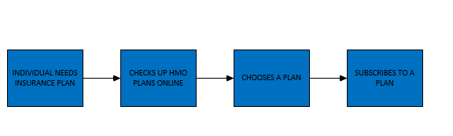 USERMAP 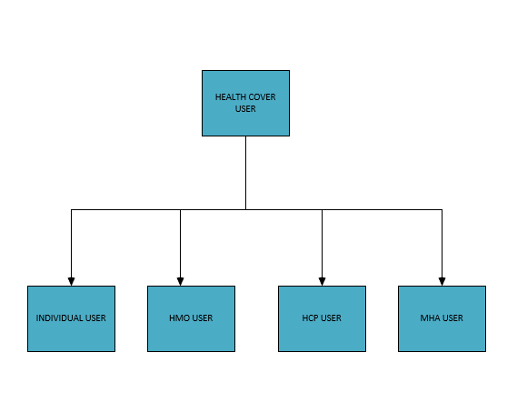

**ACTOR PROFILE & DESCRIPTION**

**Individual User**:

This is a primary user on this system. This user initiates the health cover service.

**Health Management Organisation User (HMO):**

This user is a network or organization that provides health insurance coverage to the individuals or people in need of health insurance plan.

**Hospital Care Providers (HCP):**

This user is the organization that provides health care services to the individual.

**Mutual Health Association:**

This user is a voluntary membership organization that provides health insurance services to their members.

# **SYSTEM PROCESS**

**AS-IS**

The current system is a cumbersome process characterized by a lot of challenges: lack of awareness, limited information about health supply, high administrative cost of risk pooling by private health insurance providers, high cost and inflexibility of health insurance premium payments, poor health seeking behavior of Nigerians, lack of proper structure for health insurance providers to showcase their products.

An attempt to represent the current process is provided in the figure below.

AS IS PROCESS



WILL – BE

In order to improve on this current long process, a To-Be process has been modelled that seeks to eliminate almost all the challenges associated with the current (AS-IS) process. The process has been categorized into different actors by different events.

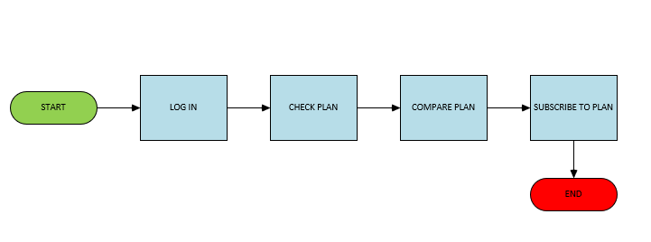a) **Registration Process**



1. **Individual Subscription Process Flow**

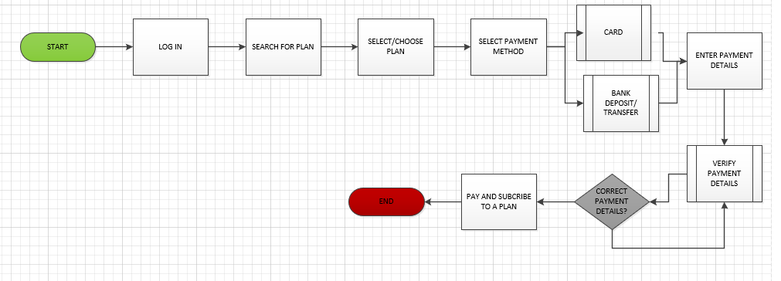

1. **Health Management Organisation Flow Process**

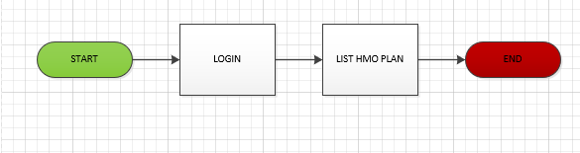

1. **Mutual Health Association Flow Process**

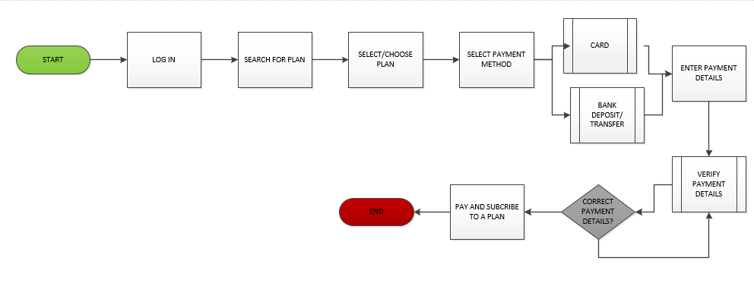

BENEFITS LISTING PROCESS

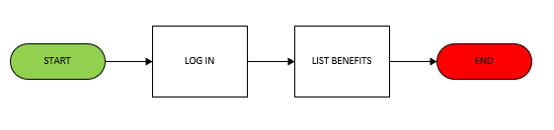

PROVIDERS



REQUIREMENTS

**FUNCTIONAL REQUIREMENTS**

These requirements listed below specifies the functions of the system

**Registration/ Profile Management**

* User must be able to download and install and the HCS App
* System should be design for both android and iOS environment
* System must have sign-up user category (Individual or corporate)
* User must select sign-up category
* User should be able to enter details in the respective fields and sign up
* System must request data entry validation/confirmation
* System should prompt user to fill compulsory fields
* System should display successful registration message
* Users should be able modify/update profile details
* User should be able to change/reset password

**Logging/Off**

* All user shall log into the system by entering his/her user id and password.
* System must allow user log-in
* User should be able to sign-off
* System must allow user sign-out

**BENEFIT MANAGEMENT**

* User should be able to create/ list health plans and benefits
* User should be able to register health providers
* User should be able to update health plans/ benefits

**PAYMENT MANAGEMENT**

* User should be able to make payments online
* System must verify user e-wallet
* System should able to prompt user to supply payment details (If E-wallet funds is not sufficient)
* User should be able to choose payment method (e-wallet. Fee for service)
* System must verify and confirm payment

**PLAN SUBSCRIPTION**

* System must allow user search/ view for plan
* System must allow user select/ pay for a plan
* System should allow user list the price for each plan
* System should allow user list benefit offer for each plan

**ADMIN MANAGEMENT**

* System should be able to approve user registration
* System should be able to activate/deactivate user account
* System should be able to reset user password
* System should be able to prompt users when new features are added

**Information Logging**

* The system should be able to collect users’ data

**NON-FUNCTIONAL REQUIREMENTS**

**Usability:**

1. Simple to Operate: The software should be easy to learn and operate; the user should not require special skills or training to operate the system.
2. Simple design: The user interface should be kept as simple as possible so as not to make the application too confusing for the user to understand i.e., user friendly interface.
3. User awareness: User manual and in-build help file will be provided for the user. Tool tip text will also be provided for quick help.

**Reliability**

1. The system should be up and running 24 x 7 x 365 and should be crash safe during 90% of its runtime.
2. Mean time between failures (MTBF): The MTBF (if any) should not be less than 1 months
3. Mean time to repair (MTTR): In case of a failure that leads to a system outage, the MTTR should not be more than 2 hours.

**Performance**

1. Short response time: Any page of the application should not take more than 1 second to load. The load time of the application should not be more than 1 seconds.
2. Population Support: The application should be able to support 1,000 concurrent users without any performance degradation.

**Supportability**

1. Advanced technologies: As technology is changing so fast, the system should be able to support new technologies.

**Integration**

1. System must have an integration capability in other to support third party applications.

**Packaging**

* The software will also be available online, and anybody may access it. Critical functions are reserved to authorized users only. e.g. the system administrator.

**Legal**

* Data from the user should adhere to the rights of data privacy of the user. All the content must be procured through legal channels and there should be no copyright violations.

**Security**

1. As the system will be dealing with delicate data, the system should be secure. The data should be stored in a highly secure manner and should be immune to any hacking attempts.

**Scalability**

* The system designed will be optimum for the 1,000 users.
* The system should be able to scale up to 500 concurrent users (if there is a need in the future) by installing additional hardware components with no degradation in the performance of the system.

**Schedule Constraints**

* The entire system should be up and running in the user’s production environment.

**Standards Constraints**

* All the documents delivered should adhere to the IEEE standards for software engineering.

USE- CASES

Essential Use-Cases

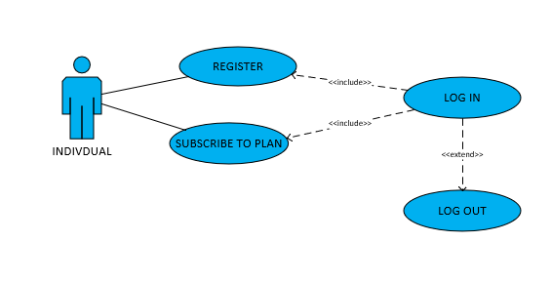

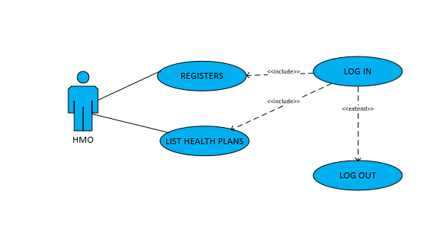

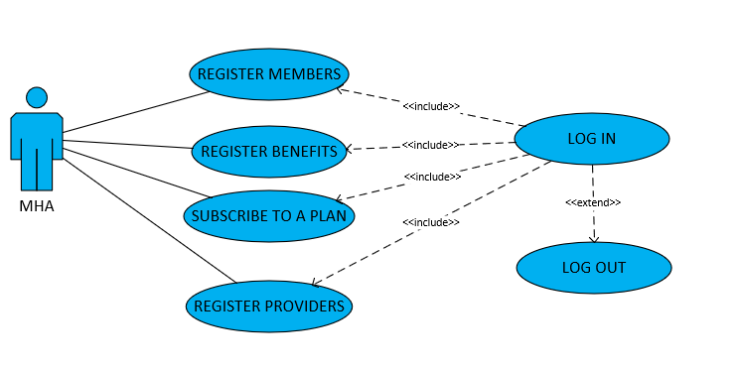

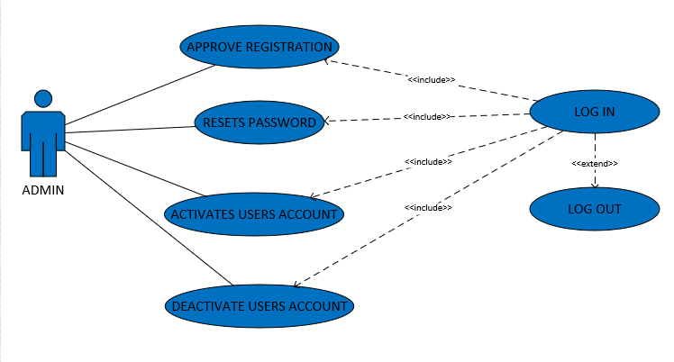

SYSTEM ARCHITECTURE

SPECIFICATION

|  |  |
| --- | --- |
| **USE CASE** | **SPECIFICATIONS** |
| **USE CASE TITLES** |  |
|  |  |
| **ACTORS** | 1. INDIVIDUALS/ MHA/HMO (Primary Users). |
|  | 2. MHA (Secondary User) |
|  | 3. HMO (Secondary User) |
|  | 4. HEALTH COVER SYSTEM (ADMIN) |
|  |  |
| **SUMMARY DESCRIPTION** | This describes how the primary users of the health cover platform search and subscribe to an health insurance services. |
|  |  |
| **PRE- CONDITIONS** | Primary user is registered on the health cover platform. |
|  | User has access to internet/mobile phone or desktop |
|  |  |
|  | 1. User is in need of Health insurance plan |
|  | 2. User logs into the health insurance platform |
|  | 3. User searches through HMO plans |
|  | 4. User selects a plan |
|  | 5. User makes payment |
|  | 6. User subscribes to a plan |
|  | 7. User |
|  |  |
| **ALTERNATIVE PATH** | 1.    No internet/Network supply |
|  | 2.    Unavailable Secondary users |
|  | 3.    Unregistered Primary User |
|  | 4.    System not responsive |
|  |  |

WIREFRAMES

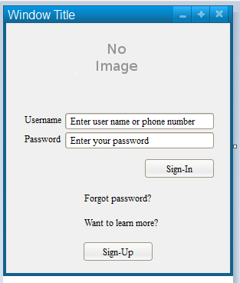

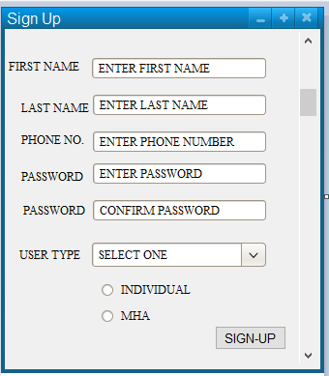

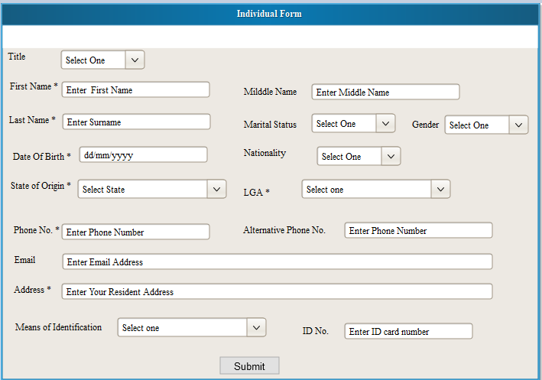

INDIVIDUAL DASHBOARD

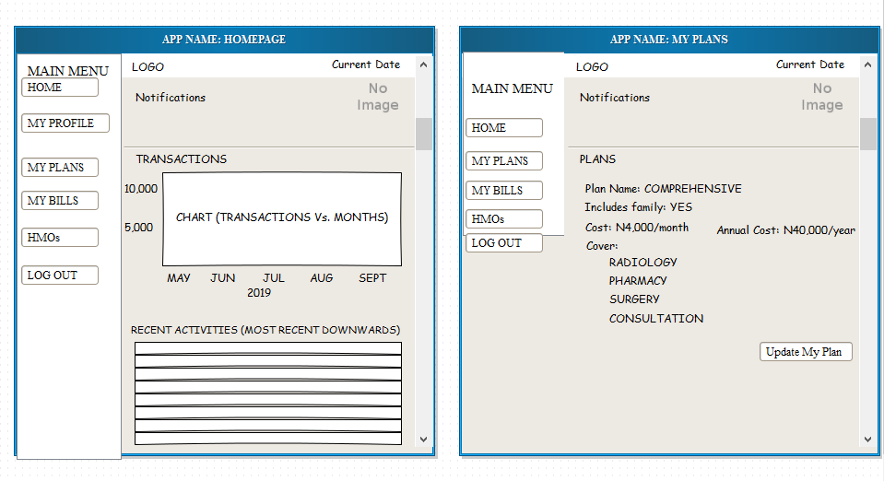

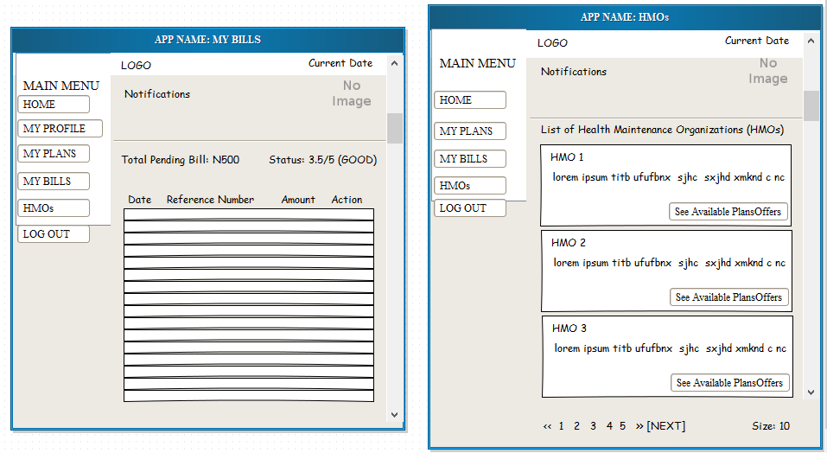

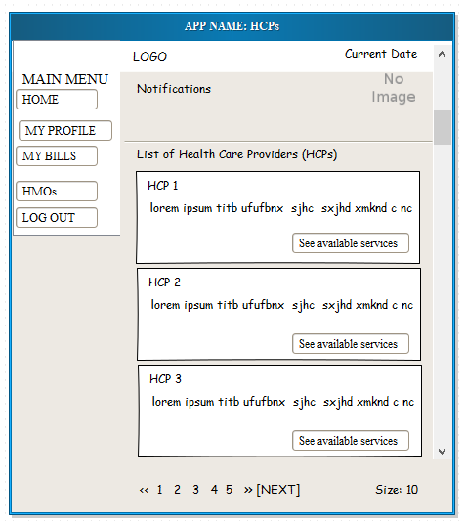

HMO PROFILE UPDATE FORM

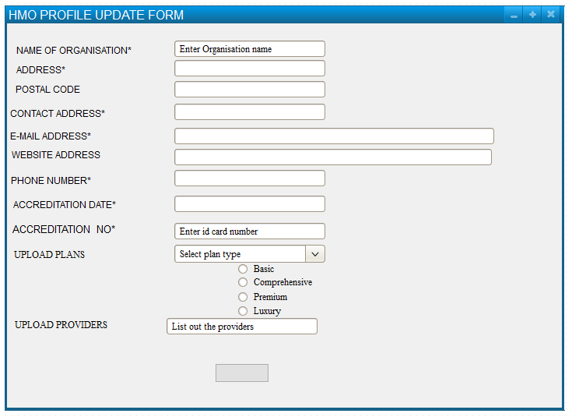

HCP PROFILE UPDATE FORM

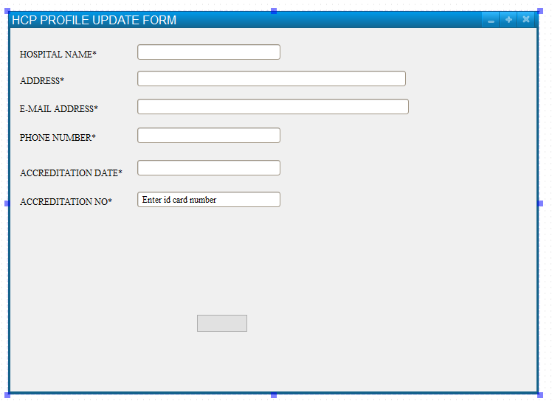

MHA PROFILE UPDATE FORM

